Phone - +919320027500 Website – painclinicofindia.com email – cipmindia@gmail.com

Date –
Invitation
To,

Sub: Invitation for Dr , Dept of , for international workshop of pain CIPM – XVII, Navi Mumbai

Dear Sir/Madam
We have organized The Comprehensive interventional pain management workshop CIPM -XVII in Navi Mumbai. The conference is held at MGM Medical college, Kamothe, Navi Mumbai from 11-14th May 2023.
The workshop will help trainees to learn basics and advances in interventional pain management. This includes Fluoroscopic as well as USG guided pain interventions.
The Faculties renowned pain physicians who from various places - international and national.
We invite Dr to join the workshop and enhance the learning in Pain management field.
The brochure and registration details are mentioned in the attached email (as given by you)

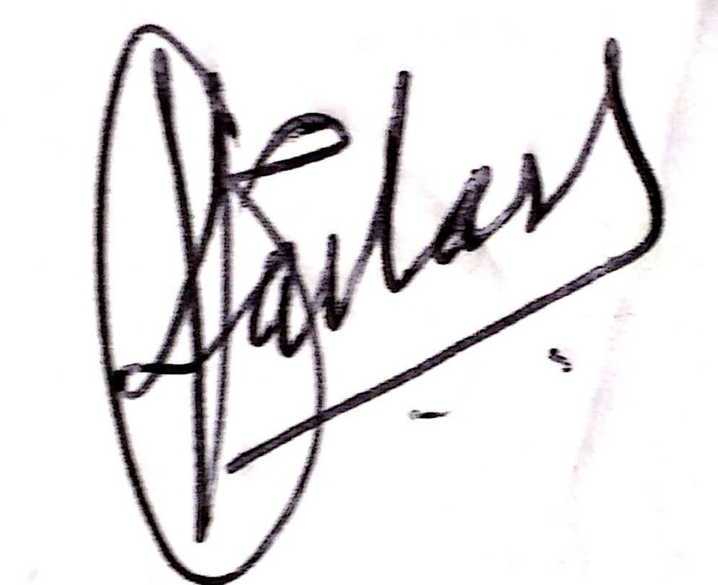
Dr. Kailash Kothari
Chairman , CIPM - XVII
Event managed by – Eazso solutions
Note : This is computer generated letter and does not need any signature

